## **Data Analyst Task**

The sales team has the following data from various sources which you have to download from the below drive

[**https://drive.google.com/drive/folders/1cfVJx6IicqLNKwWUIJG-O-htpTK3R-tE?usp=sharing**](https://drive.google.com/drive/folders/1cfVJx6IicqLNKwWUIJG-O-htpTK3R-tE?usp=sharing)

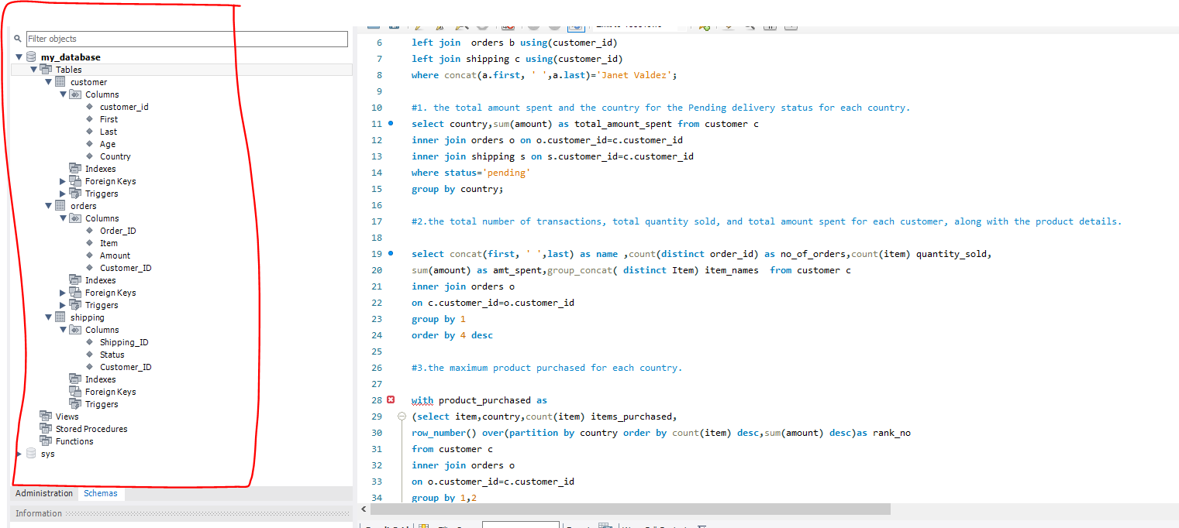

The team is trying to generate the reports for the below requirements

*#1. the total amount spent and the country for the Pending delivery status for each country.*

*select country,sum(amount) as total_amount_spent from customer c*

*inner join orders o on o.customer_id=c.customer_id*

*inner join shipping s on s.customer_id=c.customer_id*

*where status='pending'*

*group by country;*

*UK 136300*

*USA 65500*

*UAE 53800*

*#2.the total number of transactions, total quantity sold, and total amount spent for each customer, along with the product details.*

*select concat(first, ' ',last) as name ,count(distinct order_id) as no_of_orders,count(item) quantity_sold,*

*sum(amount) as amt_spent,group_concat( distinct Item) item_names from customer c*

*inner join orders o*

*on c.customer_id=o.customer_id*

*group by 1*

*order by 4 desc*

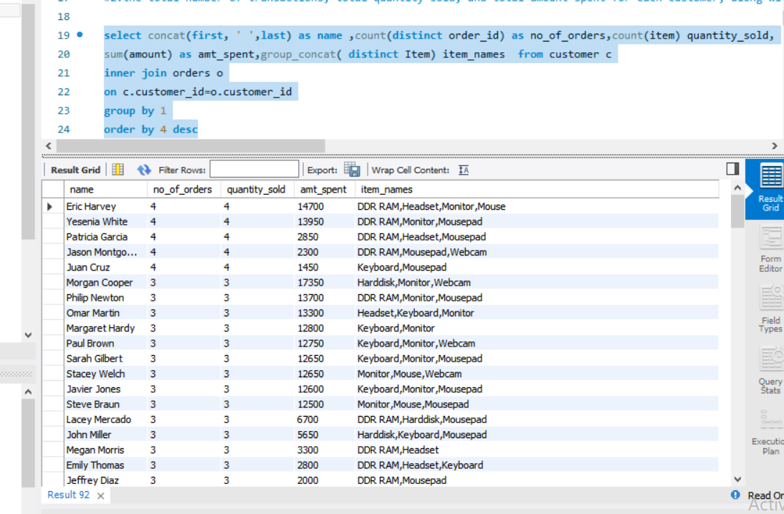

*#3.the maximum product purchased for each country.*

*with product_purchased as*

*(select item,country,count(item) items_purchased,*

*row_number() over(partition by country order by count(item) desc,sum(amount) desc)as rank_no*

*from customer c*

*inner join orders o*

*on o.customer_id=c.customer_id*

*group by 1,2*

*)*

*select item,country from product_purchased*

*where rank_no=1*

| *Keyboard* | *UAE* |
| --- | --- |
| *Mousepad* | *UK* |
| *Mousepad* | *USA* |

*#4.the most purchased product based on the age category less than 30 and above 30.*

*select * from*

*(select item as less_than_30*

*from orders o*

*inner join customer c*

*on o.customer_id =c.customer_id*

*group by item*

*order by count(case when age<30 then item end) desc*

*limit 1) a*

*cross join*

*(select item as more_than_30*

*from orders o*

*inner join customer c*

*on o.customer_id =c.customer_id*

*group by item*

*order by count(case when age>30 then item end) desc*

*limit 1) b*

*# less_than_30, more_than_30*

*'Mousepad', 'Keyboard'*

*#5.the country that had minimum transactions and sales amount.*

*with minimum_transaction as*

*(select country,count(order_id) as transactions,sum(amount) as sales_amount,*

*dense_rank() over( order by count(order_id),sum(amount)) as min_trans*

*from customer c*

*inner join orders o*

*on o.customer_id=c.customer_id*

*group by country*

*)*

*select country from minimum_transaction*

*where min_trans =1*

*Country*

*UAE*